System.Drawing.Dll and SDK Error Solution
This documentation will assist in resolving both of these issues. This error usually occurs when there is a mapped drive on the machine in question. Please follow the steps in the documentation to resolve these issues.

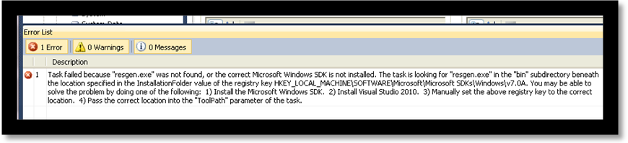

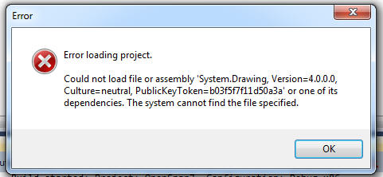

Placing files in the proper place:
- Close OpenSpan Studio and locate the Microsoft SDKs bin folder on the mapped drive.
  - Example: D:\Program Files\Microsoft SDKs\Windows\v7.1\bin
- Copy all files in bin folder (Ctrl +A, then Ctrl +C)
- Navigate to the Microsoft SDK bin folder in the C drive.
  - Example: C:\Program Files\Microsoft SDKs\Windows\v7.1\bin
- Paste copied files from bin folder in mapped drive to bin folder in C drive.
Edit Registry:
- Run regedit
- Locate the Microsoft SDKs Windows registry folder
  - Example: HKEY_LOCAL_MACHINE\SOFTWARE\Microsoft\Microsoft SDKs\Windows
- Expand folder and right click the version folder
  - Example: v7.1
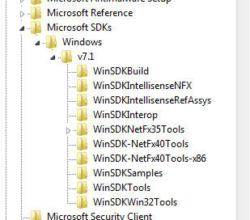

- Make sure that all register sub folder keys located underneath the 7.1 registry folder point to the primary drive (C:). If any of the registry keys refer to the secondary drive (Example: value begins with D:\Program Files\Microsoft SDKs), change them to point to the primary drive (Example: Change value to begin with C:\Program Files\Microsoft SDKs)
- Locate the Microsoft MSBUILD registry folder in Regedit
  - Example: HKEY_LOCAL_MACHINE\SOFTWARE\Microsoft\MSBuild
- Underneath the Microsoft MSBUILD registry folder there is another subfolder called ToolVersions. Underneath the ToolVersions folder you should see a 4.0 folder

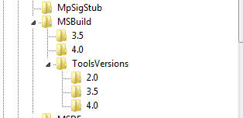
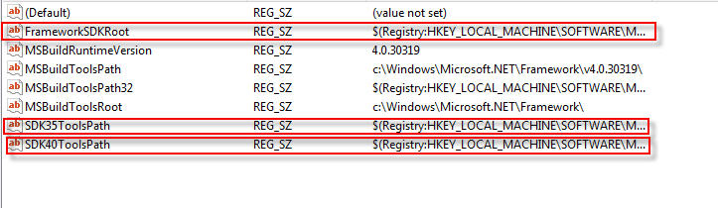
- For the keys highlighted above, change the part of the value that references the SDK version from “v7.0A” to “v7.1”
  - Example: FrameworkSDKRoot
    - Current Key Value: $(Registry:HKEY_LOCAL_MACHINE\SOFTWARE\Microsoft\Microsoft SDKs\Windows\v7.0A@InstallationFolder)
    - Change To This Key Value: $(Registry:HKEY_LOCAL_MACHINE\SOFTWARE\Microsoft\Microsoft SDKs\Windows\v7.1@InstallationFolder)
  - Example: SDK35ToolsPath
    - Current Key Value: $(Registry:HKEY_LOCAL_MACHINE\SOFTWARE\Microsoft\Microsoft SDKs\Windows\v7.0A\WinSDK-NetFx35Tools-x86@InstallationFolder)
    - Change To This Key Value: $(Registry:HKEY_LOCAL_MACHINE\SOFTWARE\Microsoft\Microsoft SDKs\Windows\v7.1\WinSDK-NetFx35Tools-x86@InstallationFolder)
  - Example: SDK40ToolsPath
    - Current Key Value: $(Registry:HKEY_LOCAL_MACHINE\SOFTWARE\Microsoft\Microsoft SDKs\Windows\v7.0A\WinSDK-NetFx40Tools-x86@InstallationFolder)
    - Change To This Key Value: $(Registry:HKEY_LOCAL_MACHINE\SOFTWARE\Microsoft\Microsoft SDKs\Windows\v7.1\WinSDK-NetFx40Tools-x86@InstallationFolder)
- Once you have changed the correct SDK version for each of the keys above, open up the SDK35ToolsPath key value under the ToolsVersion\4.0 registry sub folder.
- Inside the key you will find a section of the value which may contain an incorrect path. Remove the dashes and x86 out of the registry key value.
  - Current Key Value: $(Registry:HKEY_LOCAL_MACHINE\SOFTWARE\Microsoft\Microsoft SDKs\Windows\v7.1\WinSDK-NetFx35Tools-x86@InstallationFolder
  - Change To This Key Value: $(Registry:HKEY_LOCAL_MACHINE\SOFTWARE\Microsoft\Microsoft SDKs\Windows\v7.1\WinSDKNetFx35Tools@InstallationFolder)
- Repeat these changes under the Wow6432Node for 64-bit operating systems.
- Re –open the solution through OpenSpan Studio.
- Clean and rebuild the solution.
- After the solution has rebuilt successfully, run the solution to test.

